

2016

**Cape Breton Privateland Partnership (CBPP)**

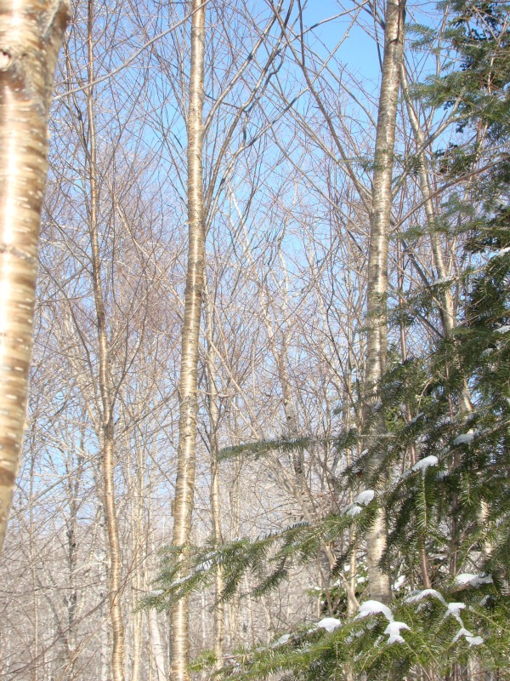

Harvest and Silviculture

Standards

30/06/2016

Cape Breton Privateland

Partnership (CBPP)

HARVEST AND SILVICULTURE

STANDARDS GUIDEBOOK

Contents

GENERAL REQUIREMENTS 3

CBPP Administration Requirements 3

Pre-work 3

Auditing Requirements 3

Membership Requirements 4

Contractor Members 4

Landowner Members 4

OPERATIONAL STANDARDS 5

General 5

Safety and Liability 5

Property Lines 5

Interpretation of Forest Management Plans 5

FSC Certified Woodlots 6

SILVICULTURE STANDARDS 6

Silviculture Technical Standards 6

Funding Requirements and Availability 7

Silviculture Claims Requirements 7

Silviculture Rates 7

Tier 1 / Tier 2 Funding system (ASF) will be used to compensate for claims submission assistance where required. 8

Special Silviculture Fund – 5% of total silviculture budget for coming year. 8

HARVESTING STANDARDS 8

Cape Breton Privateland Partnership (CBPP) Harvest and Silviculture Standards

***Treatment operations performed on CBPP member woodlots should be held to the highest professional standard. It is the intent of the CBPP to ensure the best possible results regarding forestry treatments and environmental and wildlife protection on member woodlots.***

# GENERAL REQUIREMENTS

CBPP Administration Requirements

### Pre-work

1. Provide pre-work support to manage expectations between landowner and contractor. Many landowners will discuss expectations and objectives without the assistance of CBPP but absentee and uninitiated landowners will require this service. This will be the Forest Manager’s responsibility initially where demand is low. To be re-evaluated once demand goes up. Specific scenarios likely to include some combination of the following:

PLEASE NOTE: Starting in April 2017 a forest management plan will be required to qualify for silviculture funding through cbpp.

* 1. Arrange meeting between the three parties to discuss expectations and objectives.
  2. Review pre-work checklist with landowner and contractor.
  3. *Review pre-work checklist with contractor as per landowner’s specifics. This would be a situation where CBPP is acting on behalf of the landowner.*

1. Arrange for pre-work contact or meeting with contractor to ensure health and safety requirements; stand prescriptions; and HCVF (if applicable) are realized at the operator level.
2. Document site audits and make available to the landowner, contractor and CBPP members.
3. Perform site audits on harvest, silviculture and road treatments.
4. Provide option for layout and tree marking services
   1. Cost recovery basis
   2. This is likely for non-contractor (ie. Landowner workforce) situations
   3. Landowner and contractor members will be provided with initial guidance where required but will be required to pay for extra services outside of initial guidance.

### Auditing Requirements

1. Auditing intensity: Minimum - 70% of harvesting operations; 30% of silviculture operations
2. Site inspection staff is independent from harvesting / silviculture contractor. This may be the CBPP Forest Manager or another qualified inspector.
3. Inspection results will be posted on the CBPP website, accessible by secure member login.

Audits prioritized based on the following criteria:

* 1. Harvesting activities are higher risk than silviculture
  2. Concerns or complaints expressed by member landowners
  3. HCVF are present on the woodlot
  4. Work is carried out by new contractor members
  5. Work is carried out by contractor members who have demonstrated previous non-conformance.

## Membership Requirements

Contractor Members

1. Contractors are required to inform CBPP of operations start up and completion
   1. Only ‘required’ for member lots.
2. Agree to operate to the standards of the CBPP.
3. Ecosystem based management requirements
   1. Required to manage for significant ‘Acadian Forest’ conditions when identified
      1. Tolerant hardwood or tolerant softwood dominated stands
      2. Primordial forest conditions
4. Agree to follow FSC requirements when working on FSC certified lots.
5. Agree to be subject to site audits.
6. Agree to audit results being available to CBPP members through secure member login on the CBPP website.
7. Site remediation is undertaken where required
8. Agree to follow complaints / removal process.

Landowner Members

1. ***Pre-Work Checklist -*** CBPP does not require, but strongly encourages landowners and contractors to review the following checklist prior to agreeing to undertake forest management activities.
   1. Who will contact adjacent landowners (30m of a property boundary or 100m of a dwelling for harvesting activities 30 days prior to harvest start)?
   2. Have contractor references been reviewed (suggest at least three)?
   3. Is there explicit understanding about
      1. Areas to be cut?
      2. Areas to be left? Products / Species to be harvested?
      3. Product destinations?
      4. Acceptable utilization?
   4. Are property lines clearly identified and who is responsible for this?
   5. What condition will roads be left in, who is responsible and how are costs shared?
   6. What is acceptable rutting?
   7. Is there a time of year (wet) when the job should not be carried out?
   8. Is there a defined pricing and payment schedule?
   9. Will all garbage be removed and the site left in an acceptable condition?
2. ***Contracts -***CBPP does not require, but strongly encourages its members to use contracts for work carried out. Contracts help to ensure a clear understanding of expectations for both parties. An example contract can be provided by CBPP, and is also contained in the Appendix of Forest Management Plans.
3. Unless otherwise stipulated in a contract, the landowner agrees to the CBPP audit results.
4. Required to inform CBPP of operations start up and completion
5. Required to follow CBPP harvesting / silviculture standards (BMP, OH&S, Auditing, Forest Management Guidelines, Provincial and Federal Legislation) if using non CBPP member contractor or doing work themselves.
6. Landowners must also be willing to provide on request a fair and balanced reference for any member contractors they have employed through the Partnership.
7. Landowner members can choose to either contact Partnership contractors directly or post available work within the system.
8. Ecosystem based management requirements. Required to manage for significant ‘Acadian Forest’ conditions when identified.
   1. Tolerant hardwood or softwood dominated stands
   2. Old growth conditions
9. Required to pay annual dues (Members who have let membership fees lapse may re-enter the program once account is up to date).

# OPERATIONAL STANDARDS

## General

1. Treatment operations must meet or exceed the guidelines for Best Management Practices (BMP) for Nova Scotia as outlined in the BMP Manual, 2012 developed through the Nova Forest Alliance. Available online at: (<http://novaforestalliance.com/uploads/nfa/documents/BMP_Manual_Final_Mar_2012.pdf>)
2. Health and Safety requirements are met in accordance with Occupational Health and Safety Act and the Forest Safety Society of Nova Scotia guidelines.
3. Harvesting and silviculture treatments follow management plan recommendations.
   1. Operational changes from management plan recommendations are reviewed and agreed upon with CBPP representative prior to treatment.

## Safety and Liability

Any work carried out must include appropriate safety equipment and hazard risk assessment. The best available source which includes this information is 'The Forest Professional' available online at: http://www.gov.ns.ca/lae/healthandsafety/docs/forestprofessional.pdf

A paper copy can be made available for any party with no computer access.

-All work carried out is to be in accordance the Nova Scotia Occupational Health and Safety Act including documented proof of appropriate WCB coverage, liability insurance and health and safety certification.

## Property Lines

Demonstrate a reasonable effort to establish visible property boundary lines prior to any forestry treatment being carried out. In the case where no boundary markings are evident, a survey should be carried out or an agreement reached between adjacent property owners.

## Interpretation of Forest Management Plans

Any treatment carried out within this program should be done within the context of the management plan. At a minimum (relating to silviculture), the forest management plan for the property in question should contain maps which demonstrate the current forest cover and development stage(s), a map of prescribed treatments, a water table map and an aerial photo. Supporting tables with forest inventory information should include species type, age, size dimensions (height / diameter), FEC and volume estimates.

The shapefile for each specific woodlot is available with the landowner’s permission through the group manager.

## FSC® Certified Woodlots

Harvest and silviculture treatments administered through this program and carried out on FSC certified woodlots are governed by the NSLFFPA FSC Certification Policies and Procedures manual and the Forest Stewardship Council (FSC) Maritime Standard Principles and Criteria (<http://www.fsccanada.org/maritimesstandard.htm>).

# SILVICULTURE STANDARDS

## Silviculture Technical Standards

The technical standards for silviculture are those defined through the Association for

Sustainable Forestry (ASF). There are seven categories of silviculture treatments for which funding is available with 'pre' and 'post' treatment requirements listed for each. The standards can be viewed online at <http://www.asforestry.com/default.htm>.

Silviculture treatments administered through this program and carried out on FSC certified woodlots are governed by the Forest Stewardship Council (FSC) Maritime Standard Principles and Criteria. The standard can be found online at: <http://www.fsccanada.org/maritimesstandard.htm>

## Funding Requirements and Availability

Funding for silviculture on private land is currently available through three different sources.

1. CBPP members with a current forest management plan are eligible for enhanced silviculture funding through the partnership. Available silviculture funding will vary from year to year. Member properties are prioritized for silviculture funding based on the following allocation rules (Developed and approved by the CBPP Advisory Committee):
   1. Funding will be applied to landowners, not contractors
   2. Members who have not received funding in the past will be prioritized.
   3. Funding is prioritized based on treatment need (eligible treatment window)
   4. Funding limits per woodlot will vary from year to year depending on available funds. Rough approval set initially at $8000 per woodlot.
   5. Funding application will not be approved until a workforce is identified.
   6. At the time of approval, a ‘complete by’ date will be assigned.
   7. FSC certified woodlots have a higher priority for funding.
   8. All else being equal, application date will be used to assign funding.
2. The Association for Sustainable Forestry (ASForestry.com) provides funding for silviculture on both small and large private land throughout Nova Scotia. Funding for full planting is not available through ASF directly.
3. Many of the large buyers of private wood are required to carry out silviculture on private land in Nova Scotia. For more information on this option you will need to contact the buyers directly. A list of these registered buyers is available on the DNR website (http://gov.ns.ca/natr/forestry/registry/ovrvuindx.asp).

## Silviculture Claims Requirements

Pre-assessment surveys are required for each application. Procedure for these assessments are in accordance with the ASF assessment standards with the exception that no shapefile is required for the pre-assessment. These standards can be found in appendix II and also on the ASF website (http://www.asforestry.com/PDFs/manual/AssessmentProcedures.pdf).

Post-assessment surveys are required for each completed treatment. Procedure for these assessments are in accordance with the ASF assessment standards and a shapefile is required for the completed treatment.

CBPP field staff will sample completed treatment claims randomly to ensure silviculture standards are met. Claims will not be processed for treatments that do not meet the ASF assessment standard.

## Silviculture Rates

Treatment rates are the same as those posted through the ASF. Please visit both www.cbwoodlots.org and [www.asforestry.com](http://www.asforestry.com).

### Tier 1 / Tier 2 Funding system (ASF) will be used to compensate for claims submission assistance where required.

### Alternative silviculture and habitat enhancement fund – 5% of total silviculture budget for coming year. Applications for alternative (not currently defined) treatments are submitted to the advisory committee for approval.

# HARVESTING STANDARDS

Best management practices cover most aspects of harvesting operations to an acceptable standard. The following is expanded upon to meet the desired standard of the CBPP:

1. Soil damage (rutting) prevention is key.
2. Layout trail in advance of job and use brush matting where necessary.
3. Where a degree of rutting is unavoidable, all efforts are made to keep rutting isolated to one trail and maintenance techniques are used such as;
   1. Main trails are pre-planned and brush matted.
   2. Machines are not driven through uncut areas or recreational trails.
   3. Forward wood (part loads) first on softest ground and or difficult terrain, finish load on drier ground.
   4. Where feasible, back into the woods with forwarder. Load from the back of the block working towards the landing.
   5. Use brush mats to help avoid site damage.
4. Maximum acceptable rutting averages less than 40cm deep over any 20m length.  Site remediation and landowner approval is required at or above this threshold.
5. Special attention will be paid to site remediation along the roadside of completed harvest operations.  Trails, landings, access roads, public roads, ditches, etc. will be left in good condition.
6. No sediment is running into streams as a result of trail layout and /or rutting.
7. Contractual requirements are met
8. Don't take extraction trail prep for granted (talk to operators)